***California State University, Long Beach***

Semester Project

GMI Purchase Order System

By

Nicholas Pickens

016248425

Thnick15@gmail.com

Spring 2018, IS 380 Section 01

Database Management

Professor Sophie Lee

May 16, 2018

Table of Contents

**Table of Contents2**

**File Names3**

**Table Structure4**

**Test Data5**

**All Program Code(.sql)**(**6-18)**

Setup.sql6-9

OpenPO.sql10-11

ReceivePO.sql12-13

QueryPO.sql14-15

Aging.sql16

ShortShip.sql17

SupplierMonthly.sql18

**File Names**

* **SQL Programs:**
* Setup.sql
* OpenPO.sql
* ReceivePO.sql
* QueryPO.sql
* Aging.sql
* Shortship.sql
* SupplierMonthly.sql
* **Program txt spool:**
* Setup.txt
* OpenPO.txt
* ReceivePO.txt
* QueryPO.txt
* Aging.txt
* Shortship.txt
* SupplierMonthly.txt
* TableStructure.txt
* TestData.txt

*(****Note:*** *commands for spooling of data and set linesize were manually used to produce results.)*

**Table Structure**

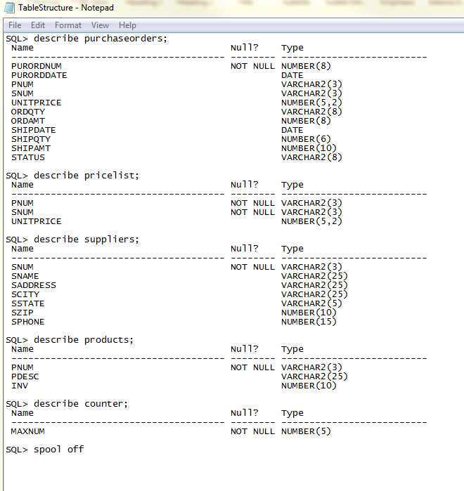

**Test Data**

